MA684
HW 3
Hongbo Xue
U72135949

Read about PIs and CIs in Chapter 5 of KKM and N, and R² and the ANOVA for the regression in Chapter 7. (We’ll talk about correlation when we meet, which is covered in Chapter 6.)

1. Some results from the regression predicting height (in inches) from femur length (in inches), from last week’s homework. First, some summary data on the independent (femur length) and dependent (height) variables in the analysis:

Data on n=40 adults
Variable | mean | sd
Femur length  Height | 17.60  59.89 | 1.16  2.64

A summary of the regression results:

Linear regression predicting height (inches) from femur length (inches)
 | Parameter  Estimate | Standard  Error | t-value*  (df) | p-value | 95% CI
Intercept  Femur Length | 24.85  1.99 | ---  0.175 | ---  11.39 | ---  <0.001 | ---  1.34 , 2.34
* the t-statistic has 38 df
** the standard error about the regression line was s(y|x) = 1.27

1A. What is the predicted height for a subject with a femur of 17.5 inches?
Answer:
24.85+1.99(17.5)=59.6750

1B. By hand, find a 95% confidence interval for this predicted height. Give an interpretation of this interval.
Answer:
From the formula, we can find
Y_{x0}=59.68
t=2.021
Mean=17.6
SD=1.16
So we can get 59.68+/-0.4075=(59.2725,60.0875)
We can say 95% confident that the mean height for femur length of 17.5 inches is between 59.2725 and 60.0875 inches.

1C. By hand, find a 95% prediction interval for this predicted height. Give an interpretation of this interval – be clear on how the interpretation of a PI differs from a CI.
Answer:
Y_{x0}=59.68
t=2.021
Mean=17.6
SD=1.16
So we can get 59.68+/-2.5988=(57.0812,62.2788)
We can say 95% confident that 95% for femur length of 17.5 inches are between 57.0812 and 62.2788 inches.

1D. Find these intervals using a statistical computing package (SAS and SPSS users, note that ID=27 has a femur length of 17.5 inches).
Answer:


2. A study examined the association between weight and blood pressure in a sample of n=300 adults. Weight was measured as BMI (Body Mass Index), a measure of relative weight-for-height; BMI less than 18.5 is considered underweight, between 18.5 and 25 considered normal weight, 25 to 30 considered overweight, and above 30 considered obese. The following is a partial ANOVA table predicting systolic blood pressure from BMI:

Anova for the regression
Source | SS | d.f. | MS | F
Model  Error | 23750  127090 | 1  298 | 23750  426.4765 | 55.6889
Total | 150840 | 299

2A. Complete the above ANOVA table. State the null hypothesis that is tested by the F-statistic from the ANOVA table. Give the p-value corresponding to this F-statistic, and give an interpretation for this result.
Answer:
Null hypothesis-----No association between weight and blood pressure.(R²=0)
P-value=9.37765e-13
From the p-value we can find the p-value smaller than 0.05, which means we can reject our null hypothesis for the entry population.

2B. Find and interpret the R² from the regression summarized above.
Answer:
R²=23750/150840=0.1575
R² is always between 0 and 1. In here, R²=0.1575 that means there is not stronger association between weight and blood pressure.

4. (Based on a study from the AJPH). A study was conducted to examine factors associated with quality of life. Data from a hypothetical sample of n=100 adult subjects are saved in the attached ‘qolstudy’ data sets. Variables in the data set are: 1) id - an id number, ranging from 1 to 100; 2) sexfemale - coded 1 for females, 0 for males; 3) age – in years; 4) educyears – years of education (12 corresponds to a high school graduate, 16 to a college grad); 5) income – yearly income in thousands of dollars; 6) married – coded 1 for those married/partnered, 0 otherwise; 7) socialnetwork – the number of close friends the respond could turn to for help or advice; 8) genhealth – self-reported general health coded 1 for excellent, 2 for good, 3 for fair, and 4 for poor; and 9) qol – self-reported quality of life, ranging from 28 to 418 in this sample, with higher values indicating better quality of life. The general health variable can be thought of as ordinal, but for these analyses we will treat the general health variable as a continuous measurement variable.

We are interested in education, income, and general health as predictors of quality of life, and want to determine which is the stronger/more important predictor of quality of life.

4A. Run three separate simple regression models predicting quality of life from education, income, and general health, respectively. Report the R-squares (not the ‘adjusted R-square, which is also given in the computer output), F-statistics, and p-values from the ANOVA tables from these regressions.

Answer:
Education:


Income:
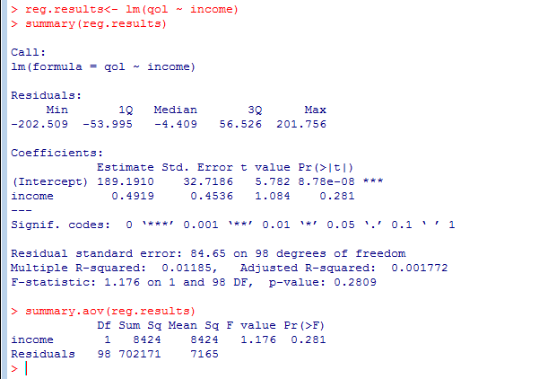

General health:


4B.Which of these 3 predictors is significantly related to quality of life? Explain.
Answer:
Compare these 3 predictors p-value. We can find general health is smaller than others. So we can say general health is significantly related to quality of life.

4C.Which of these three predictors is the strongest predictor of quality of life? Explain. Give an interpretation of the R-square from the model for the strongest predictor of quality of life.
Answer:
We can compare R² in these 3 predictors. For education, R² is equal to 0.06717; for Income, R² is equal to 0.01185; for general health, R² is equal to 0.1366. R² is always between 0 and 1. If R² close to 1 which means it has stronger association. The value of general health is bigger than others. So we can say general health is the strongest predictor of quality of life.

